February Street Cleat Shopping Centre Content

A classic and clean sneaker with a twist makes a welcome return in the Skechers Street Cleat! This blast from the past is a retro fave and is available in a variety of colours from SKECHERS (insert shopping centre name)!
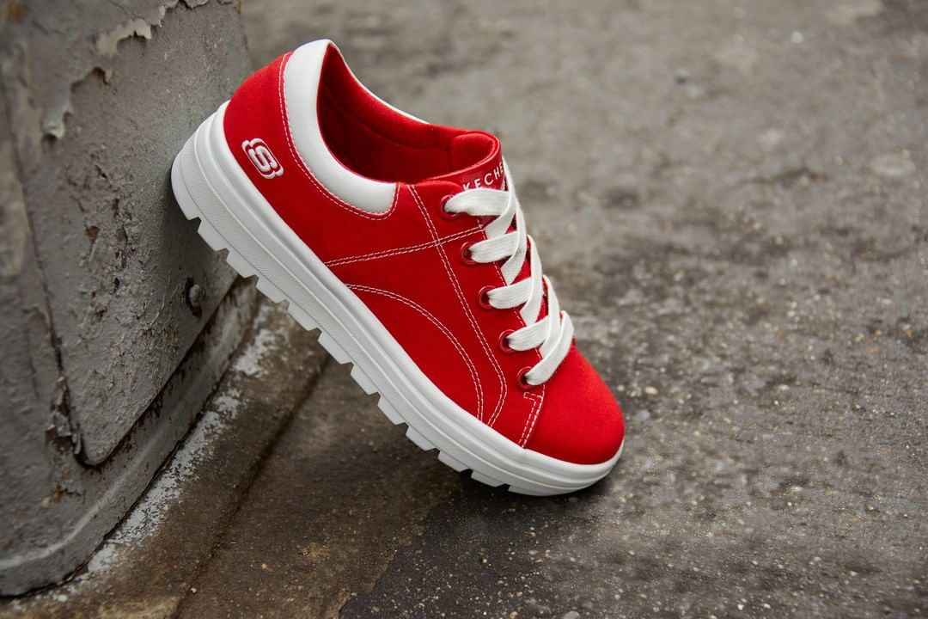
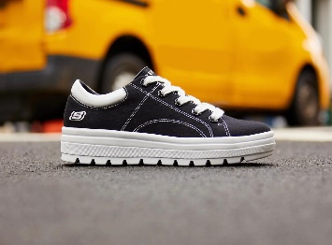

Facebook: SkechersIE
Instagram: skechersireland
Twitter: SkechersIE

