Best Menswear Valentine’s Gift Guide 2022
Know you want to spoil him but not sure how? Introducing the Best Menswear Gift Guide for all your Valentine’s Day needs!
Our talented team are ready in store with the expertise and knowledge necessary to ensure a top-quality shopping experience for all our customers.
With a wide range of brands and styles including Tommy Hilfiger, Remus Uomo, Bugatti, Calvin Klein, and Marco Capelli, to name a few, you can be sure there’s something here to suit all the special man in your life.
With the best staff, the best brands, the best products, put your trust in Best Menswear this Valentine’s and all you’ll need to worry about is your wrapping skills!

Brand | Product Name | Price | Image
BOSS | BOSS Black - 2 Pack Gift Set And Playing Cards | €34.95 | 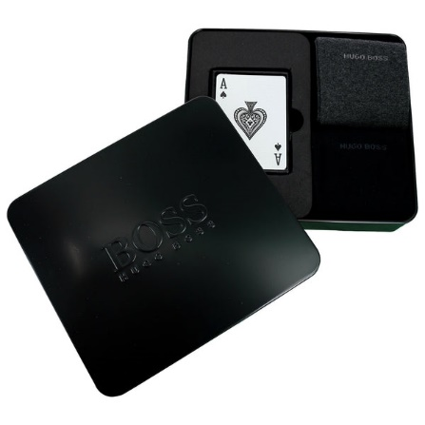
BOSS | BOSS Dark Blue - 4 Pack Gift Set Socks Metal Box | €34.95 | 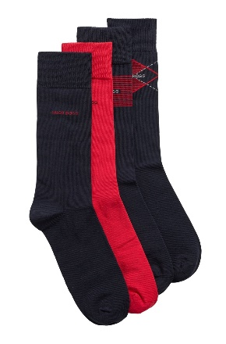
Tommy Hilfiger | Tommy Hilfiger Navy - Seasonal 5pk Gift Box | €25.60 | 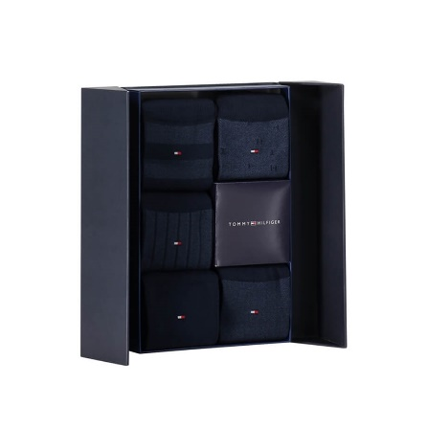
Swole Panda | Swole Panda Multi - Animal 3 Pack Gift Set | €24.00 | 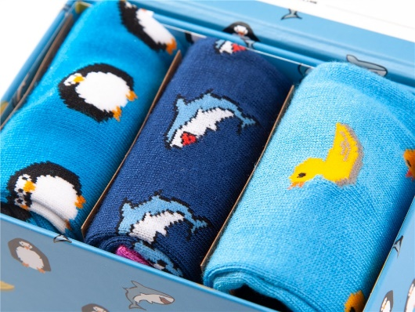
BOSS | Regular Fit Pyjama Set | €96.00 | 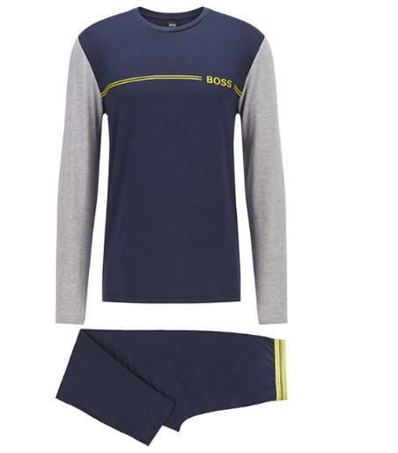
BOSS | Gift Box Wallet & Cardholder | €150.00 | 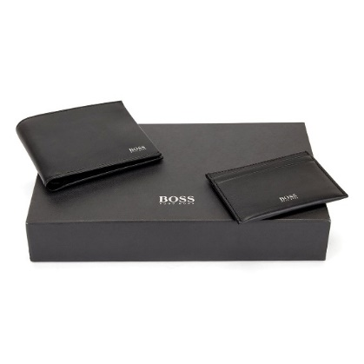
Calvin Klein | Calvin Klein Black - 3 Pack | €37.60 | 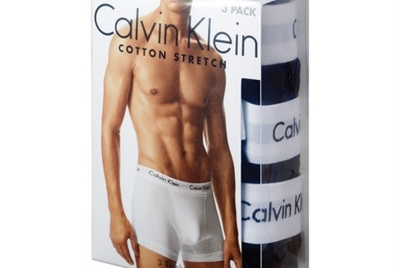
Tommy Hilfiger | Tommy Hilfiger Blue - Tommy Logo Hood | €119.95 | 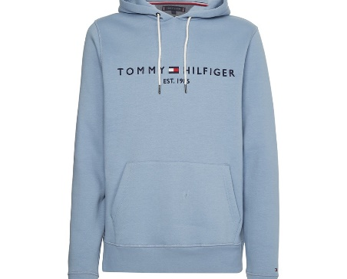
BOSS | BOSS Green - Saturn Low Profile Mxmt | €170.00 | 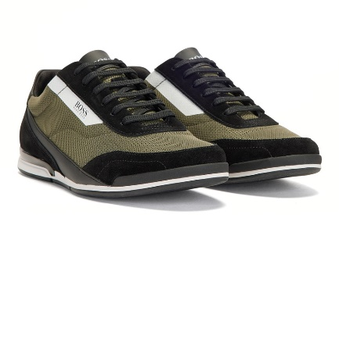
Tommy Jeans | Tommy Jeans Navy/Burg - Colorblock Zip Through Jacket | €139.90 | 